Volume of Cylinders
(Remember to show all your work and communicate your thinking clearly.)

- If both of these cans of pizza sauce are cylinders, which is the better buy?
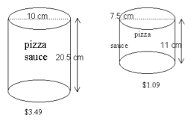

- The height of a cylinder is the same length as the circumference of its base. Its measured height is 125.66cm. Calculate the volume.

- A clay planter has the shape of a right triangular prism. Inside the planter is a cylindrical hole. Calculate the volume of clay needed to make the planter.
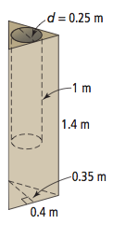

- Some Japanese bathtubs are in the shape of a cylinder.
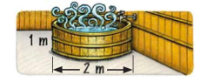
- Calculate the volume of water if the tub is filled to a depth of 0.6m

- If the volume of water is 1.256 m3, how deep is the water?

- If the water is already 0.5m deep, how much more water is needed to fill it to a depth of 0.7m?

- What volume of concrete is required to build this foot bridge?
